107 YEARS OF SUPPORTING FORMBY’S VETERANS

In the beginning!
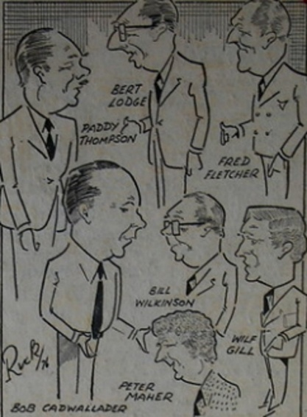
Formby Royal British Legion began in 1919 as the "Demobilised Sailors' and Soldiers' Association," founded by Percy Evans and Mr. Job, later joining the national British Legion in 1921. The branch established a popular social club on Whitehouse Lane in the post-WWII era, which closed in 2015, while continuing to support local veterans.

The Early History of the Legion was a classic rags to riches story. As President Bert Lodge explained in a newspaper interview in around 1976. We started off with a hut, £25 in the kitty and about 200 members – it became the biggest Club in Formby having grown with the town’s population

At the time Mr. Lodge was probably the longest serving and best known member in the Legion. He had been on the committee for over 20 years and had been President for 17. The hut was on land which became the car park I was very proud the way the members got down to starting the rebuilding added Mr Lodge. That was probably the best part of our development. No one was afraid to take their coats off! Lady members brought the money in believed Mr. Lodge – and one-armed bandits.
No-one can sell raffle tickets like the ladies he said.

At that time the Legion’s finances are looked after by treasurer Wilf Gill – who by chance just happens to be a local bank manager. Mr. Gill was originally a farmers Son from Lamplugh in Cumberland. Talking about the Legion, he added, ‘I like challenges and that’s what this club presented when I joined 13 years ago. As well as his work with the Legion, Mr.Gill is also treasurer of the Formby Show and Freshfields, a past president of the Rotary Club and a Magistrate on the North Sefton Bench.

Legion Vice Chairman, Bill Wilkinson was the last council official official to be left in Formby after local government re-organisation in 1974. He was not sure whether things had changed for the better. Before we used to be on First Name Terms with a lot of residents. Said Bill who was Works Superintendent for the Council.
People used to bring us their problems and we would deal with them right away. Now we seem to have lost that personal touch. People don’t know where to go – Southport, Crosby or Bootle. I’m the only Council official left in Formby.’ Bill had been on the club committee for 18 years and had done council work for 221/2 years. Ten weeks after this interview was published, he would be retiring.

At the time of this interview with the senior members of the Legion the interview was not complete without some mention off a man who has earned himself the title of ‘Mr. British Legion’ – Paddy Thompson, the Vice President. Until 1958 Mr. Thompson was an R.S.M. at Formby’s Harington Barracks. He left after 26 years in the Army. He was awarded the MBE in 1953 for service in Korea and in 1961 had the rare honour of being called up to join the Yeoman of the Guard – the Queen’s official bodyguard. There are only 60 members in the whole country. Now he works for a light engineering firm. If you ask him where he’s seen service a broad grin spreads over his face and he replies simply - Everywhere!’

And Now….

Half a Century later from that interview and the picture is very different! Oakleaf Hall and the Royal British Legion Club is now 4 houses. The only remnant of them ever being there is the Bowling Club.

Instead of meeting in the Club, the committee now meets in the home of Mr. and Mrs. Ken Ward. Ken is Formby’s Branch President, Poppy Appeal Organiser, Deputy Standard Bearer as well as being West Lancashire and Merseyside County’s Vice President and Training Officer – this is in addition to his work with St Peter’s Church and 3 choirs!

The membership is no longer on 4 figures – sadly it is only 48 in total! The Branch Committee is made up of a small team of dedicated members who do as much as they can to support the Veterans of Formby and Hightown with regular Fundraising events – such as the MVT Day and Quiz Night held recently.

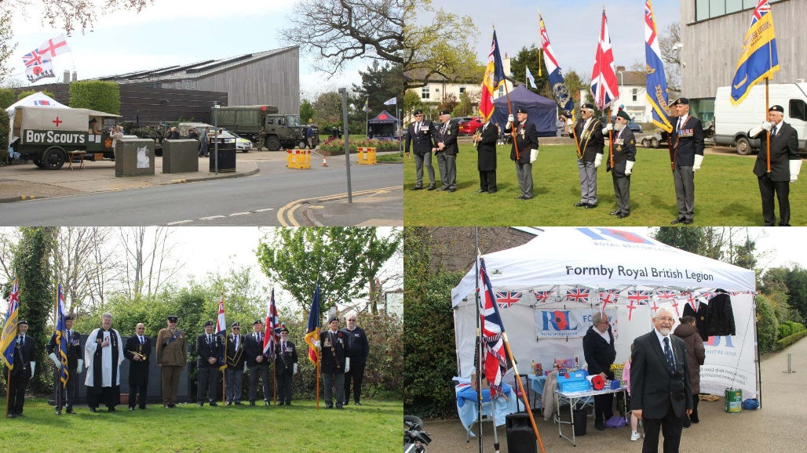

However, there is only so much this small team can do and so they are looking for new members to join their LOCAL Royal British Legion and help to continue the work supporting veterans of all ages.

If you are interested in finding out more then please contact

formbyrblandwomenssection@outlook.com

Alternatively, come along to a coffee morning hosted by The Bay Horse on Wednesday 15th July 2026 at 10 - 12 to find out more information

